Batch: A2 Roll No.: 16010322014
Experiment / assignment / tutorial No.__10__
Grade: AA / AB / BB / BC / CC / CD /DD
Signature of the Staff In-charge with date

TITLE: Familiarization of Sensor hub BoosterPack and TIVA C series Launchpad
AIM: Interface different sensors with ARM CORTEX M4- TIVA Launchpad and send the data serially through LM flasher
OUTCOME: Explore advances and recent trends in embedded systems

Board Overview:
- Sensor Hub BoosterPack
- TIVA C series Launchpad

The Sensor Hub BoosterPack includes five motion and environmental sensors. It also enables RF expansion and access to user LEDs and buttons. The hardware is designed to enable innovative applications that fuse sensor information and Tiva C Series software processing through the functionality of the Tiva C Series Launchpad.

The BOOSTXL-SENSHUB BoosterPack offers the following features: TMP006 infrared object temperature sensor
9-axis Inven Sense MPU9150 motion sensor:
- 3-axis acceleration
- 3-axis gyroscope
- 3-axis magnetometer
- Bosch BMP180 pressure sensor
- Intersil ISL29023 ambient and infrared light sensor
- Sensirion SHT21 humidity sensor
- Two user pushbuttons
- One user LED
- One power LED
- EM connector for additional wireless expansion

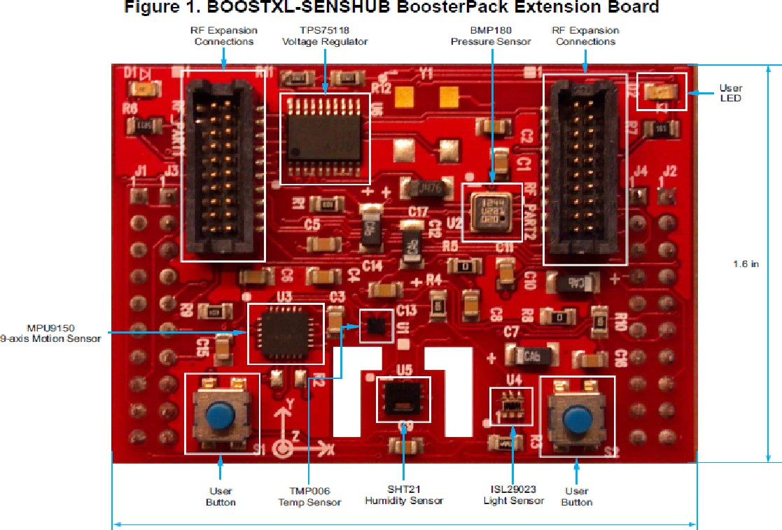

BoosterPack XL Interface Connections
  - TMP006 Temperature Sensor
The TMP006 provides both direct and indirect temperature measurements. It contains an on-chip temperature sensor to directly measure ambient temperature conditions. It also allows contactless infrared object temperature measurement

InvenSense MPU9150 9-Axis Motion Sensor
The MPU9150 is a 3-axis accelerometer, 3-axis gyroscope, and 3-axis magnetometer in a single package.This device is the primary motion sensor on the Sensor Hub. It is used by the demonstration software as the raw motion inputs, which are fused by a direct
cosine matrix into roll, pitch, and yaw measurements.

Intersil ISL29023 Ambient and Infrared Light Sensor
The ISL29023 provides sensor measurements of light conditions across both the ambient (human-visible) spectrum and the infrared spectrum

Sensirion SHT21 Humidity Sensor
The SHT21 provides relative humidity measurements

Bosch BMP180 Barometric Pressure Sensor
The BMP180 measures barometric pressure conditions. It can be used to enhance the motion sensor by determining relative changes in altitude.

Tiva Launchpad:
    - The Texas Instruments Tiva C Series microcontrollers (MCUs) are low-power, versatile and smart devices. The Tiva C Series consists of several devices that feature different sets of peripherals and are targeted for various applications.
    - The Tiva C Series MCUs provide both high performance for mixed-signal applications and low power architecture for power critical applications. The Tiva C Series MCUs are supported by TivaWare™ for C Series for software development.

Features of TM4C123GH6PM:
- It supports Thumb2 Technology, which means it supports 16/32-bit code. It consumes 26% less memory & is 25% faster when compared to pure 32-bit microcontrollers. This means, it provides the optimum mix of 16-bit and 32-bit microcontroller application requirements.
- It consists of a battery-backed hibernation module that provides logic to switch power off to the main processor and its peripherals while the processor is idle. The features of this module include low-battery detection, signaling and interrupt generation, with optional wake-up on low battery.
- The power consumption is as low as 370 A/MHz. It takes 500 s to wake up from low-power modes. The current consumption of Real Time Clock is 1.7A and it also supports internal and external power control.
- It has six physical GPIO (General Purpose Input Output) blocks, six 16/32-bit and six 32/64-bit general purpose timers, 32 dedicated 32-bit single-precision registers, also addressable as 16 double word registers.
- TM4C123GH6PM devices support flexible clocking system.
- It has an internal precision oscillator, external main oscillator with PLL(Phase Locked Loop) support, internal low frequency oscillator and real-time-clock through Hibernation module.
- It has saturated math for signal processing.
- It supports atomic bit manipulation and Read-Modify-Write using bit-banding.
- It has single cycle multiply and hardware divider module.
- The device has 256KB of Flash Memory, 32KB single-cycle SRAM and 2KB EEPROM. The memory
- is used efficiently because of unaligned data access.
- It has two motion control modules each with eight high-resolution PWM outputs.
- The device supports IEEE754 compliant single-precision floating-point unit.
- The debugger access that the device supports are JTAG and Serial Wire Debug - ETM (Embedded Trace Macrocell) available through Keil and IAR emulators
- The serial connectivity includes peripherals such as USB 2.0 (OTG/Host/Device), 8 - UART (with IrDA, 9-bit and ISO7816 support), 6 -
I2C, 4 - SPI (Serial Port Interface), Microwire or TI synchronous serial interfaces and 2 - CAN.

Pin diagram of TM4C123GH6PM

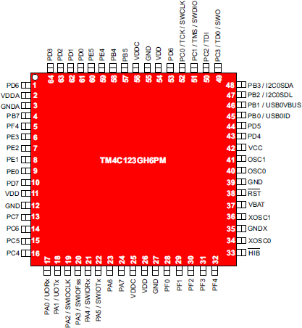
Figure: 1 pin diagram of TM4C123GH6PM

Software tools used: Students are expected to mention the tools used
CCS- Code Composer Studio LLM Flash Magic
Tera Term

Procedure:

- Connect the TM4C123GH6PM LaunchPad to your PC using a USB cable.
- Ensure the jumper settings are correct (factory default) so that the onboard ICDI (In-Circuit Debug Interface) is active.
- If you plan to use UART0 for communication, connect:
  - PA0 → UART0 RX
  - PA1 → UART0 TX

CCS

- Open Code Composer Studio (CCS). Go to File → New → CCS Project.
Enter project name (e.g., LED_Blink_TM4C). Select:
- Device: TM4C123GH6PM
- Connection: Stellaris ICDI (on-board debugger)
- Project Type: Empty Project with main.c
- Add necessary TivaWare library paths (if using driverlib).
- Write your C program (e.g., LED blinking, UART communication, sensor interface).
- Build the project

LLM Flash Magic

- Open Flash Magic.
- Configure as follows:
  - Device: LPC1768 → (NOTE: for TM4C, select the correct COM port manually)
  - COM Port: (Check in Device Manager → Ports)
  - Baud Rate: 115200 (typical)
  - Interface: None (ISP bootloader via UART0)
  - Hex File: Browse and select your .hex file generated by CCS.
- Enter Bootloader Mode:
- Hold SW1 (Reset) button, press and release SW2 (BOOTLOAD) button on the LaunchPad, then release SW1.
- Click Start in Flash Magic.
  - It will erase, program, and verify the code on the MCU.
- Once complete, reset the board

Tera Term

- Open Tera Term.
Select the COM Port that corresponds to your TM4C board (check Device Manager).
- Go to Setup → Serial Port, set parameters:
  - Baud rate: 115200 (or as set in your UART code)

Data bits: 8
  - Parity: None

Stop bits: 1
  - Flow control: None
- Click OK.
- Open the terminal window

Observations: (Students are expected to showcase observations from the demonstration used during laboratory set up)

SHT21
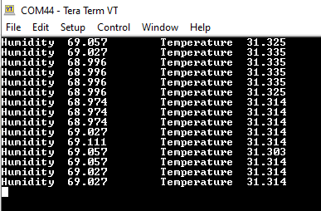

ISL29023
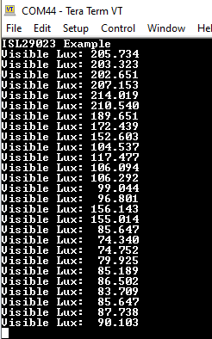

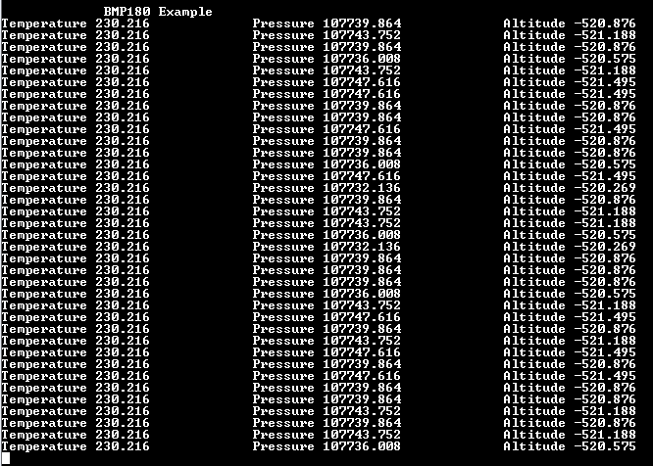
BMP180

TMP006
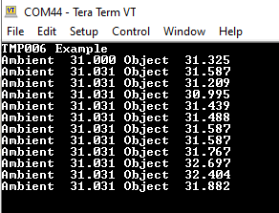

MPU91509

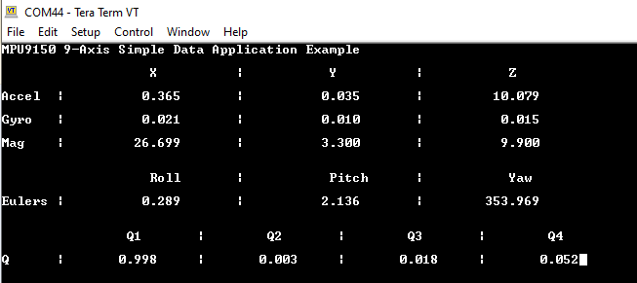

Exercise:
Name of the sensor | Function/use of sensor | Application area (where it can be used for IoT )
TMP006 | Infrared (IR) temperature sensor that measures the temperature of objects  without physical contact by detecting emitted infrared radiation. | - Smart home thermostats  - Industrial equipment monitoring  - Medical devices  (contactless temperature measurement)  - Environmental monitoring systems

MPU9150 | 9-axis motion tracking  sensor combining a 3-axis accelerometer, 3-axis gyroscope, and 3-axis magnetometer (compass). Used for detecting orientation, motion, and acceleration | - Wearable fitness trackers  - Drones and robotics for navigation and stabilization  - Smart vehicles (motion detection, tilt sensing)  - Gesture-controlled IoT devices
ISL29023 | Ambient light and infrared sensor that  measures visible and IR light intensity to simulate human eye response. Helps control brightness levels. | - Smart lighting systems (auto brightness control)  - Smartphones/tablets (adaptive display brightness)  - Energy-efficient buildings  - Smart street lighting
SHT21 | Temperature and humidity sensor that  provides accurate digital measurements of environmental temperature and relative humidity. | - Smart agriculture (climate monitoring)  - Weather stations  - Smart HVAC systems  - Food storage and logistics monitoring
BMP180 | Barometric pressure sensor that measures  atmospheric pressure and can also estimate altitude and weather changes. | - Weather monitoring stations  - Drones (altitude control)  - Indoor navigation systems  - Environmental and smart city applications

POST LAB questions:

- What is Internet of things?
The Internet of Things (IoT) refers to a network of interconnected physical devices that can collect, share, and exchange data with each other over the internet. These devices
are embedded with sensors, microcontrollers, software, and communication modules that enable them to sense the environment, process data, and take actions — often with minimal human intervention.

Examples of IoT Devices
  - Smart home devices: Smart bulbs, thermostats, and smart speakers.
  - Industrial IoT (IIoT): Machines with predictive maintenance systems.
  - Healthcare IoT: Smart wearables and remote patient monitors.
  - Agricultural IoT: Soil moisture and weather monitoring systems.
  - Smart cities: Connected traffic lights, waste management, and pollution monitoring.

How sensors and microcontrollers are useful for creation of embedded AI applications discuss in detail.

Sensors/Actuators: Collect data (temperature, pressure, motion, etc.) or perform actions (turning motors, lights, etc.).
Microcontrollers/Microprocessors: Process data locally (edge computing). Connectivity: Wi-Fi, Bluetooth, ZigBee, LoRa, or cellular networks for data transmission.
Cloud/Server: For storing, analyzing, and visualizing large amounts of data. User Interface: Mobile apps or dashboards for user interaction and control.

Embedded AI (Artificial Intelligence) refers to integrating AI algorithms directly into small embedded systems (like microcontrollers) rather than relying solely on
cloud-based processing.
This allows real-time, low-power, and privacy-preserving intelligent behavior on the edge.

Conclusion:In this procedure, we successfully demonstrated how to use Code Composer Studio (CCS), Flash Magic, and Tera Term together for programming and testing the TM4C123GH6PM microcontroller.

Signature of faculty in-charge with date

Department of Electronics and Telecommunication Engineering
LY B.Tech/EXTC/RTOS/Sem-VII/June-Dec 2025 Page 10 of

